Kubernetes Documentation

Setting up of environment:

An AWS EC2 instance is created and we ssh into it

Setting Kubernetes using Minikube:

To install Kubernetes using Minikube, we require the latest docker driver or any other compatible driver

Here we will be using the latest docker driver

Install kubectl :

* curl -LO [https://dl.k8s.io/release/**$(**curl -L -s https://dl.k8s.io/release/stable.txt**)**/bin/linux/amd64/kubectl](https://dl.k8s.io/release/$(curl%20-L%20-s%20https://dl.k8s.io/release/stable.txt)/bin/linux/amd64/kubectl)
* To validate the binary file: sudo install -o root -g root -m 0755 kubectl /usr/local/bin/kubectl
* sudo install -o root -g root -m 0755 kubectl /usr/local/bin/kubectl

Check the installation by using the following command:

kubectl version --client

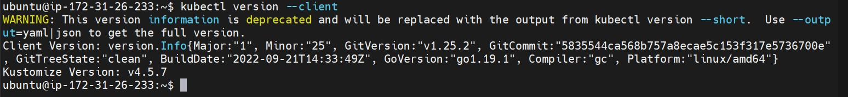

Now to install Minikube, we use the following set of commands:

* wget <https://storage.googleapis.com/minikube/releases/latest/minikube-linux-amd64>
* sudo cp minikube-linux-amd64 /usr/local/bin/Minikube
* sudo chmod 755 /usr/local/bin/Minikube
* minikube version

After verifying the version, we use “minikube start ” command to start kubernetes.

Creating the first Pod deployment:

Using the kubectl command we deploy a basic hello-node using the below command:

* Kubectl create deployment hello-node –image=registry.k8s.io/echoserver:1.4

This will spin up a basic hello-node deployment, we can check the deployment, pods and events using the below command

We now expose the deployment to port 8080:

Creating pod and checking its details:

We use the “kubectl run” command to spin up a pod, here we r creating nginx

Creating PODS with YAML file:

yaml files can be used to create a pod

in the yaml file we have to specify the configuration and the image details that are required to create a pod

Replica Set:

Replica set is used when the same pod has to be creates in multiple numbers of the same type and configuration, this is done to balance the load and divide the traffic

The replica key is used to define the number of replicas to be created

Deployment:

The yaml file can be used to deploy deployments

We have to specify the tier and make minor changes and specify the kind to deployment, this yaml file will create a deployment.

Services:

We can create a service by setting the kind to service.

